**Working with POST Requests**

**1. Add a request to the collection, edit the name, give a link *https://api.postman.com/workspaces* and select POST method**

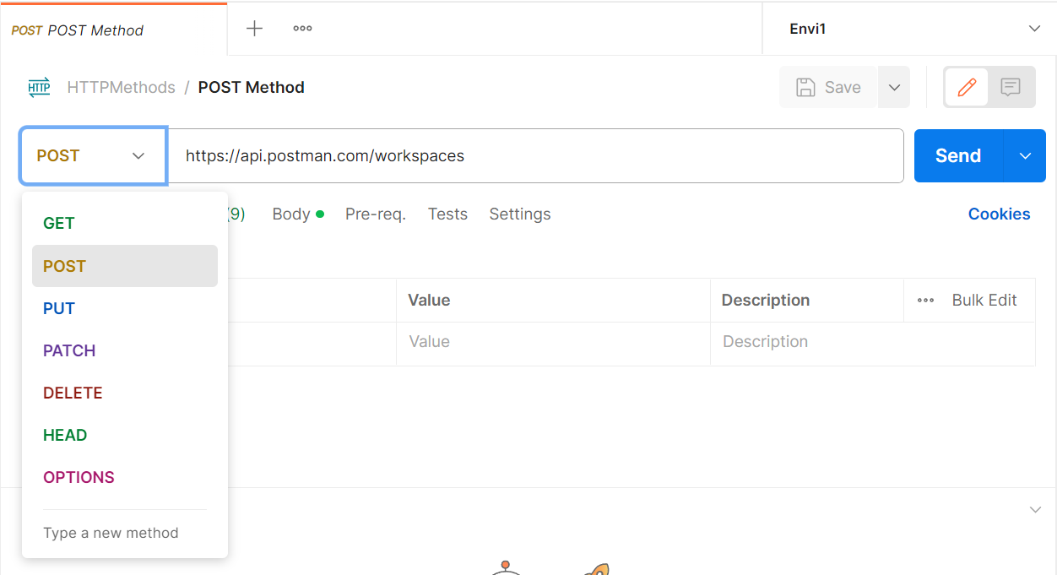

**2. Go to Body section, Select raw and JSON as shown below**

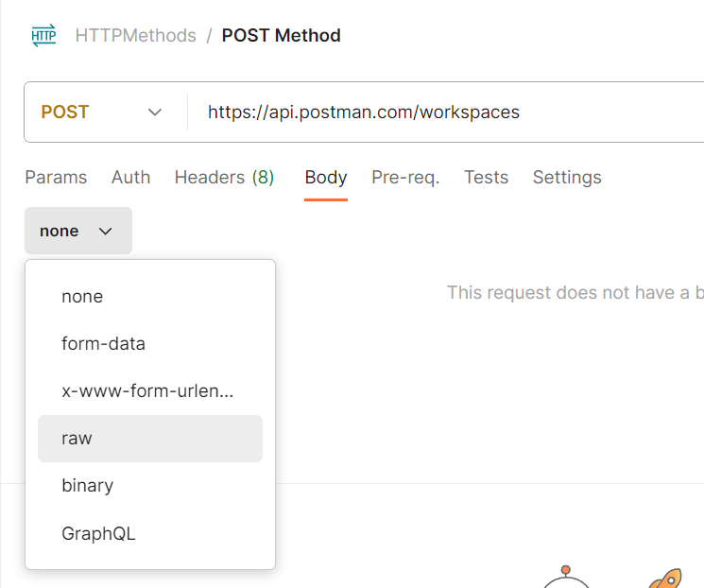

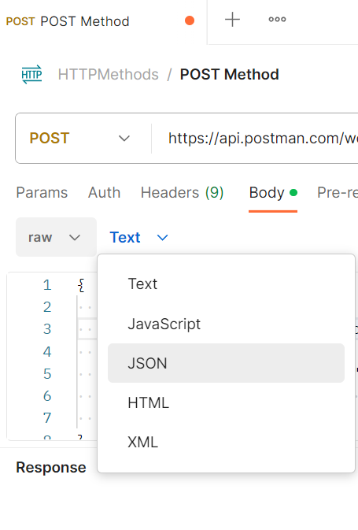

**3. Add JSON for a workspace**

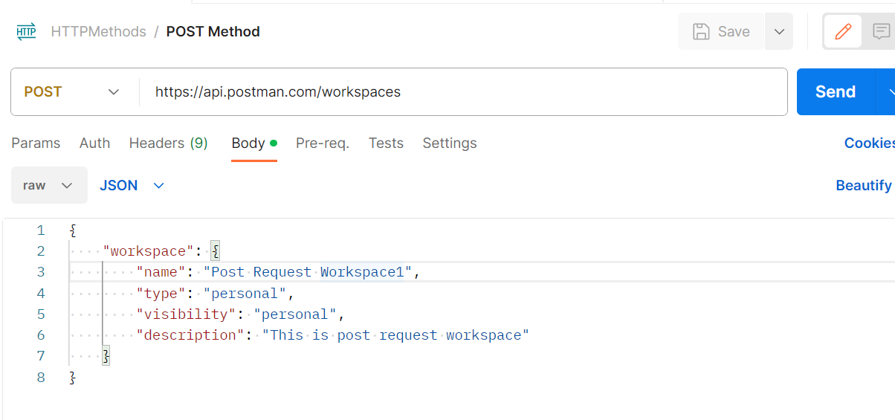

**4. Save and click on send. Observe Response and new workspace is created**

